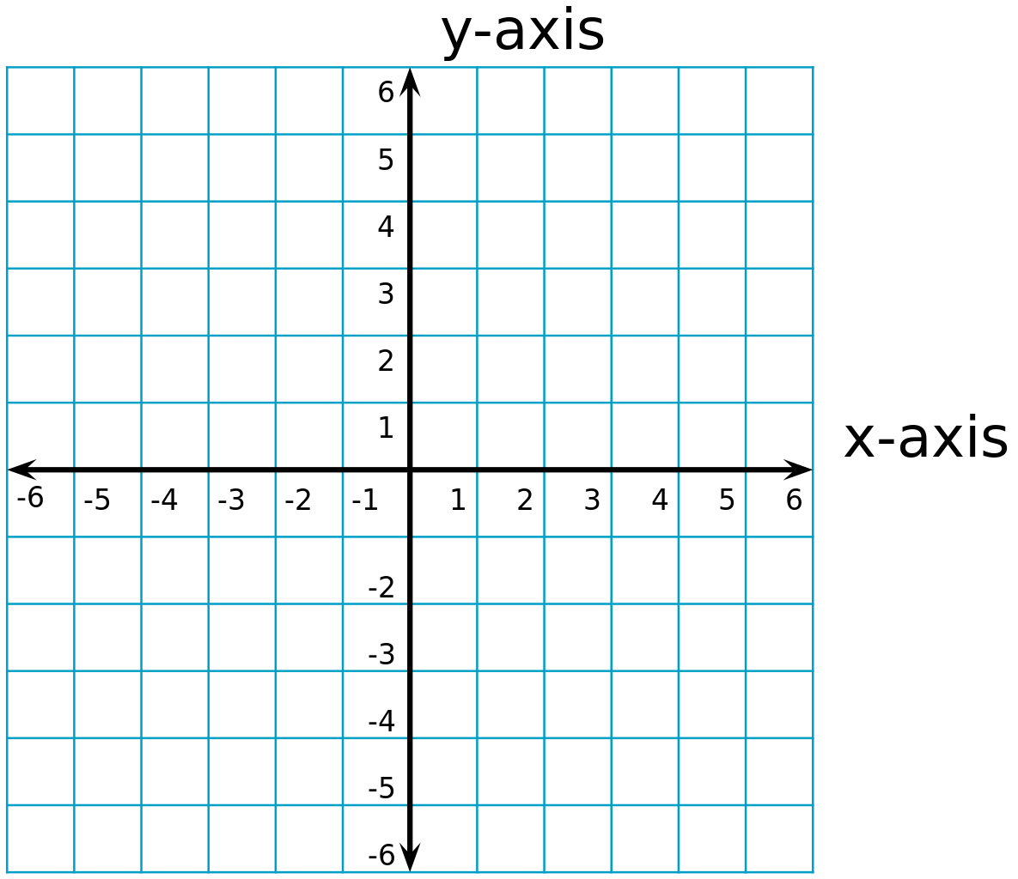
Y= 2x-5
Y=-2x+2


Y= x+1
Y=-2x+4

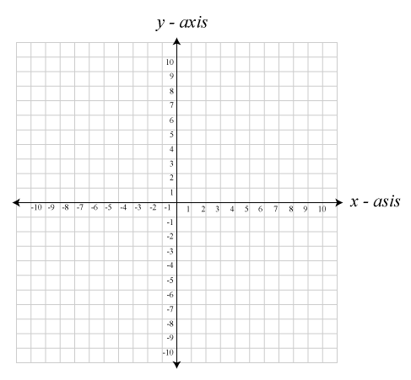

Y=4x-7
Y=-3x

Y=-2x+4
Y=2x
Y=x-4
Y=-2x-4

Y=2x-10
Y=-x

